**SUPERLUXE & Partners and artist ‘DEEP’ sign**

**Exclusive Fine Art Partnership**

SUPERLUXE & Partners, a Jersey-based Global Art Representation business and DEEP, represented by artist David Prescott, a Jersey-based Artist, have signed an Art Partnership Agreement that sees SUPERLUXE bring a unique, specially commissioned Lionel Messi Fractured Glass Artwork exclusively to the global Fine Art Print and Digital Art market.

DEEP, best known for his mixed-media art, has developed a unique 1 off artwork in glass of the world-famous Footballer, Lionel Messi. The 1/1 Original will be made available by SUPERLUXE & Partners as Limited Edition Artworks in a Large format Edition of 150 Fine Art Prints, a Medium format Edition of 295, and printed on SUPERLUXE’s exclusive Glass ‘Curtisium AROI’ glass as an Edition of 295. There will also be 1,000 NFTs designed in collaboration with Jersey NFT artist Jay Shaughnessey.

The Messi artwork will form part of a wider collection of fine art by DEEP to be offered by SUPERLUXE. Lionel Messi currently has over 504 million Followers on Instagram, which is expected to grow to over 700 million as the World Cup 2026 approaches.

SUPERLUXE will offer early collectors and investors a unique opportunity to acquire one of the Limited Edition Messi artworks before the price increases. Collectors will also receive exclusive Lionel Messi wines from the new launched Collection. All formats are marketed, sold and fulfilled through the SUPERLUXE.IO Fine Art Platform, as well as via in-person art events hosted by SUPERLUXE & Partners.

Speaking about the Art Partnership, artist DEEP (aka David Prescott) said *“I am thrilled to be partnering with James and SUPERLUXE & Partners. Their trajectory since inception is interstellar, and thats the kind of team I want to partner and journey with.  Their work ethic is unmatched and attention to detail is something I greatly respect and appreciate. I have huge plans for my work and brand, and that needs to be matched by those around me. I feel that I have finally found my "kin" in SUPERLUXE.”*

James A Matthewson, Founder & CEO at SUPERLUXE & Partners, also commented saying that “We first saw DEEP’s work a while back when he created the incredible piece of Prince Charles. We are delighted that, through this Private Lionel Messi Commission, our paths have brought us together and this exclusive artwork for SUPERLUXE adds an iconic footballer to our portfolio. Something we currently don’t have.”

SUPERLUXE & Partners (Jersey) and [SUPERLUXE.io](http://SUPERLUXE.io/) (BVI) is led by James A Matthewson, who brings 20+ years experience of working with some of the most prestigious luxury brands from across the globe.

James can be contacted on +44 7797 777507 or [james@superluxe.art](mailto:james@superluxe.art) and will help Art Collectors and Investors with the purchase of Glen Fox fine art collection from SUPERLUXE.

**Notes to Editors:**

Date of Release:  08 February 2025

Contact: James A Matthewson +44 7797 777507 / [james@superluxe.art](mailto:james@superluxe.art)

Website: [superluxe.io](http://superluxe.io/)

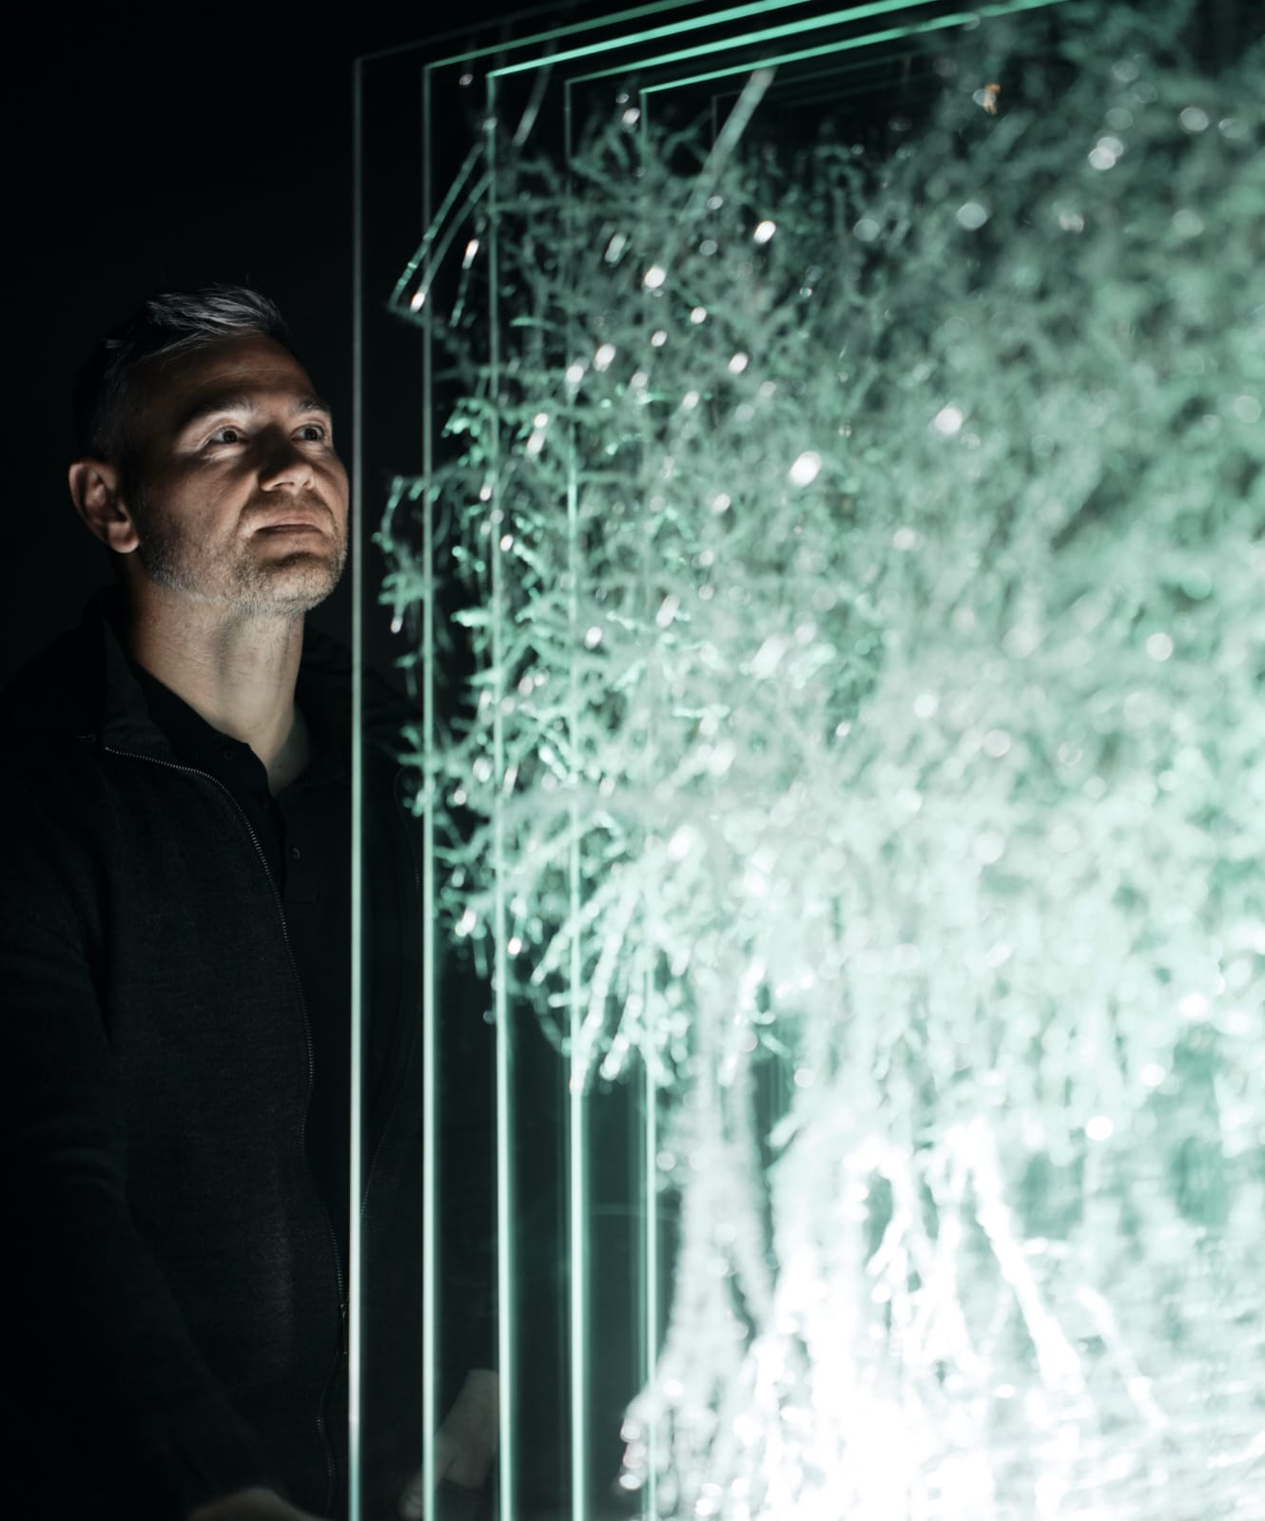

**DEEP aka David Prescott**

DEEP (b. 1981) is an English contemporary visual artist, based in Jersey, Channel Islands. Drawing inspiration from Pop Art and Neorealism, he specialises in smashed glass sculpture, wood etching and nail artistry. His work explores the interplay between strength and fragility, capturing raw emotion and resilience through unconventional materials.

David's artistic journey began while working in demolition, where he found himself contemplating the fate of discarded nails and shattered glass. Rather than seeing them as mere debris, he transformed them into striking works of art. His process — wielding hammers and sharp metal bolts to create deliberate fractures in glass — balances brutality with precision, ensuring each piece is entirely unique.

Fascinated by the human condition, David’s art metaphorically examines how imperfections and fractures often reveal the most compelling aspects of our identity. This philosophy extends to his wood etching, where subjects emerge only through the excavation of the surface, exposing the raw, hidden beauty within.

His work initially debuted in the *Mixtape* exhibition at Private & Public Gallery, and more recently in CCA International’s recent exhibit “Clash”. , David is relentlessly pushing forward, refining his craft in preparation for his first solo exhibition. With an unwavering vision, he continues to break boundaries, both literally and artistically.